Application for
EHF’s Holy Currencies Incubation Program
Instructions
Please send responses to the following questions, along with a letter of support from the Head of Congregation. The letter should also indicate the awareness and support from the vestry or Bishop’s committee to participate in the Incubation Program.
Participation in Holy Currencies requires forming a team that will commit to working together to develop a new ministry or initiative designed to strengthen the health of the community. Teams that meet regularly benefit greatly from the incubation program. This application can be viewed as a first step in that process. The responses to the application questions below should not be assigned to a single person for completion but should be the product of a conversation among key participants of the initiative proposed.
For new community ministries that have not yet started, please answer questions to the best of your abilities. We encourage you to consult with an EHF Congregational Engagement Officer as you are considering applying to discuss your idea and how Holy Currencies could benefit its development.
Sr. Congregational Engagement Officers:
Eric Moen emoen@episcopalhealth.org
Willie Bennett wbennett@episcopalhealth.org
We are accepting applications for the program through June 14, 2024. Applications should be sent by email to congregations@episcopalhealth.org
Holy Currencies Key Dates
- May 1, 2024: applications released
- June 14, 2024: applications due
- June 14–June 21, 2024: application review may include a phone call with EHF and KI to discuss application for short-listed applicants, if needed
- By June 28, 2024: selected congregations and church teams notified
- August 27, 2024: Online pre-orientation with Holy Currencies Teams
- September 13–14, 2024: two day in-person orientation weekend at The Retreat at Artesian Lakes in Cleveland, Texas. Lodging and meals are covered by EHF
- October 2024-January 2025: monthly, 2-hour evening Tuesday evening webinars for your team with Kaleidoscope Institute and EHF to learn more about the application of all six currencies. Teams will also complete their assignments and create a “ministry business plan” that strategically leverages the currencies, increases sustainability, and strengthens community connection.
  - Holy Currencies Webinar Sessions (Tuesdays @ 6-8PM)
    - Webinar 1: October 8th
    - Webinar 2: November 12th
    - Webinar 3: December 3rd
    - Webinar 4: January 14th
- March 2025: opportunity to solidify your ministry plan resulting from the incubation process and request further coaching support.

Administrative Information
- Congregation Name:

- Contact Person and Title or Role (can be clergy or lay leader):

- Contact information:
- Phone:
- Email address:

The Initiative
- What is the community ministry you are proposing and what is your vision for how it will contribute to a healthy community? Who will be better off and how? See EHF’s definition of a healthy community (Appendix A). (100 words max)

- Is this an existing or new ministry?

- How did you develop the idea for the ministry? (This may include data, community conversation, or other historical background) (150 words max)

- What are the strategies and activities associated with this ministry and how will they contribute to your vision for a healthy community? (200 words max)

- How might you track the performance of this ministry such as a) how much you do; b) how well you do it; c) the difference made; d) who is better off? (150 words max)

- What are the financial needs of this ministry per year, and how is that money generated? What other human or material resources are being contributed that make the ministry sustainable, and by whom? (150 words max)

- What individuals or groups within your church have been involved in supporting this ministry? (50 words max)

- Does/would the ministry involve organizations and individuals outside of church, and if so, how do/would they participate? (100 words max)

- What challenges have you had or do you foresee with this ministry that you have not solved (e.g. sustainability, changing community needs, not connecting with the right people, doesn’t involve enough community partners, etc.) (200 words max)

- What are the hoped-for outcomes of participation in the Holy Currencies Ministry Incubation Program? (150 words max)

General questions about the vision of your church and community (not necessarily related to the ministry you are proposing)

- What are the strengths of your church and/or community in general, and where do you see opportunities for improvement that haven’t been developed yet? (200 words max)

- What is a hope you have for your church in the next year? (100 words max)

- Are there any major church initiatives such as a building project, capital campaign or church-wide programs that your congregation will be focused on in the next year? If so, is the initiative you are proposing connected to that priority? (100 words max)

- Please list the team members who will commit to participate in the in-person training on September 30 – October 1 and the monthly webinars. We require a minimum of 6 people from each team to participate, with a maximum of 8; this can include community partners. All proposed members of your core team should have reviewed the overview of this program on the EHF website and agree to fully participate to the best of their ability throughout the Holy Currencies Incubation program. Additional team members may participate in the monthly webinars calls focused on each currency:

Name:
Role in current initiative:
Name:
Role in current initiative:
Name:
Role in current initiative:
Name:
Role in current initiative:
Name:
Role in current initiative:
Name:
Role in current initiative:

Please list names of those who participated in developing this proposal:

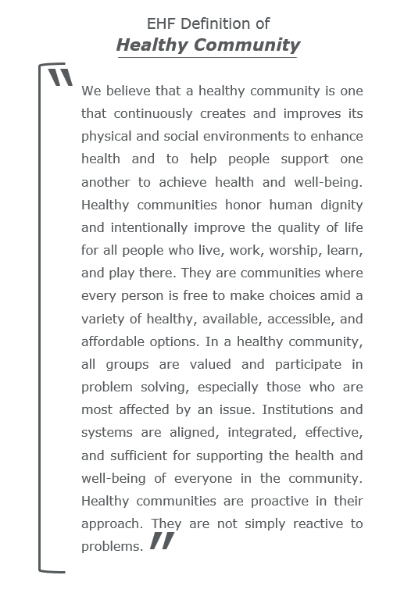
APPENDIX A

