Application for
EHF’s Holy Currencies Idea Incubation Program
Instructions
Please send responses to the following questions, along with a statement of support from the Head of Congregation.
Participation in Holy Currencies requires forming a team that will commit to learning and working together to develop an idea for a new ministry or initiative designed to strengthen the health of the community.
Teams that meet regularly benefit greatly from the incubation program. This application can be viewed as a first step in that process. The responses to the application questions below should not be assigned to a single person for completion but should be the product of a conversation among key participants of the initiative proposed.
We encourage you to consult with an EHF Congregational Engagement Officer as you are considering applying to discuss your interest and how Holy Currencies could benefit this ministry idea exploration.
Congregational Engagement Officers:
Eric Moen emoen@episcopalhealth.org
Willie Bennett wbennett@episcopalhealth.org
We are accepting applications for the program through June 30, 2021. Applications should be sent by email to congregations@episcopalhealth.org

Holy Currencies Key Dates
June 30, 2021: applications due
July 1 - 28, 2021: application review may include a phone call with
EHF and KI to discuss application if needed
By July 30, 2021: selected congregations and church teams notified
August 31, 2021: on-line orientation with your Congregational Holy Currencies Team (2 hours)
September-November 2021: bi-weekly 1.5 hour evening webinars
(likely Tuesdays) for your team with Kaleidoscope Institute and EHF to learn more about the application of all six currencies. Teams will learn steps to create internal and external inventories, engage with your community and incubate a ministry idea that meets a community need.
Spring 2022: opportunity to apply for the Holy Currencies Ministry Incubator to build out your sustainable ministry plan utilizing the Holy Currencies framework.

Administrative Information
- Congregation Name:

- Team Contact Person and Title or Role (can be clergy or lay leader):

- Contact information:
- Phone:
- Email address:

Short Answer Questions
- Tell about any current outreach ministries your congregation may have or be involved with in the community. Please also include names of any community partners or organizations you work with.

- How are congregational outreach decisions made? Is there an outreach committee, staff person or individuals responsible for leading outreach? How will they be involved in this team?

- Tell about any population in the community you may be curious about or something you are seeing that needs to be addressed.

- What are the strengths of your church and community in general?

- What is a hope you share for your church in the next year?

- How will the head of congregation and the congregation be informed about the work of this team?

- Please list the team members who will commit to participate in the webinar training in the fall. We require a minimum of 4 people from each team to participate, with a maximum of 6. All proposed members of your core team should have reviewed the overview of this program on the EHF website or watched the one-hour informational webinar. All need to agree to fully participate to the best of their ability throughout the Holy Currencies Idea Incubation program.

Name:
Email and phone number
Name:
Email and phone number
Name:
Email and phone number
Name:
Email and phone number
Name:
Email and phone number
Name:
Email and phone number

Please list names of those who participated in this application process:

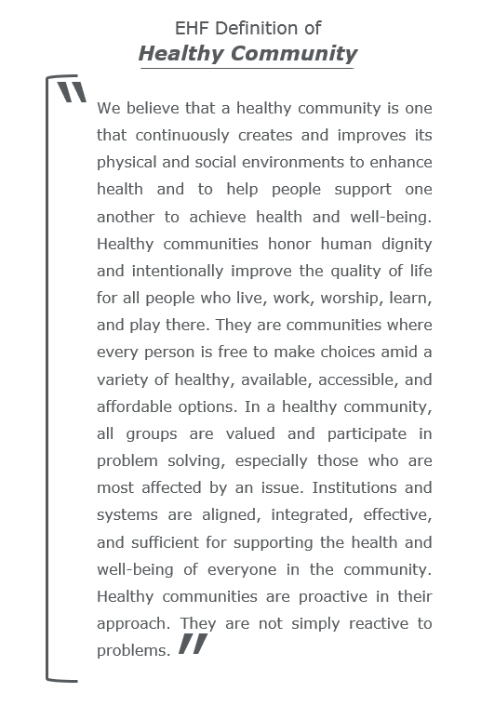
APPENDIX A

